Report of Day 1

|  |
| --- |
| **MAHIMA SHETTY** |
| **4AL15EC045** |
| **8th sem, A sec** |

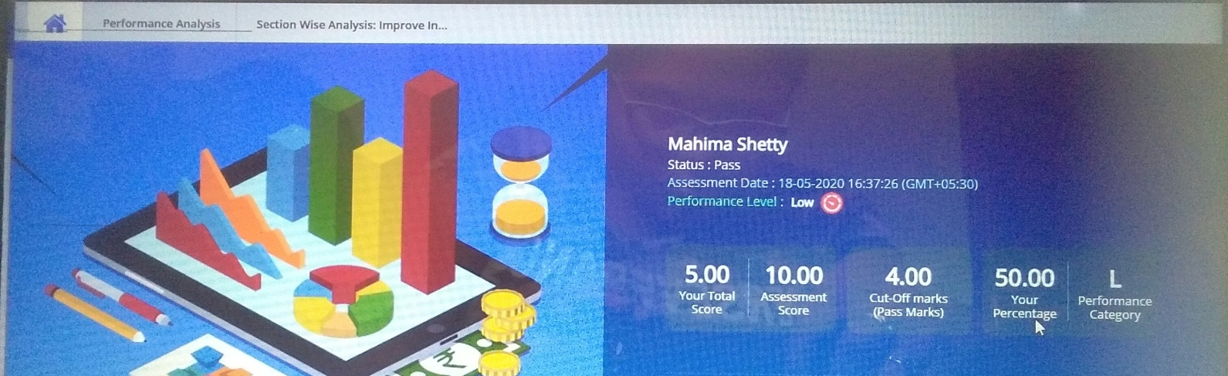

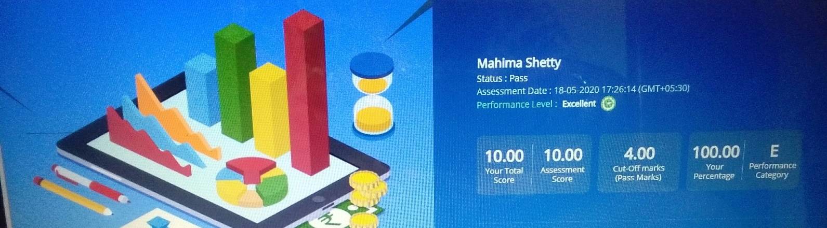

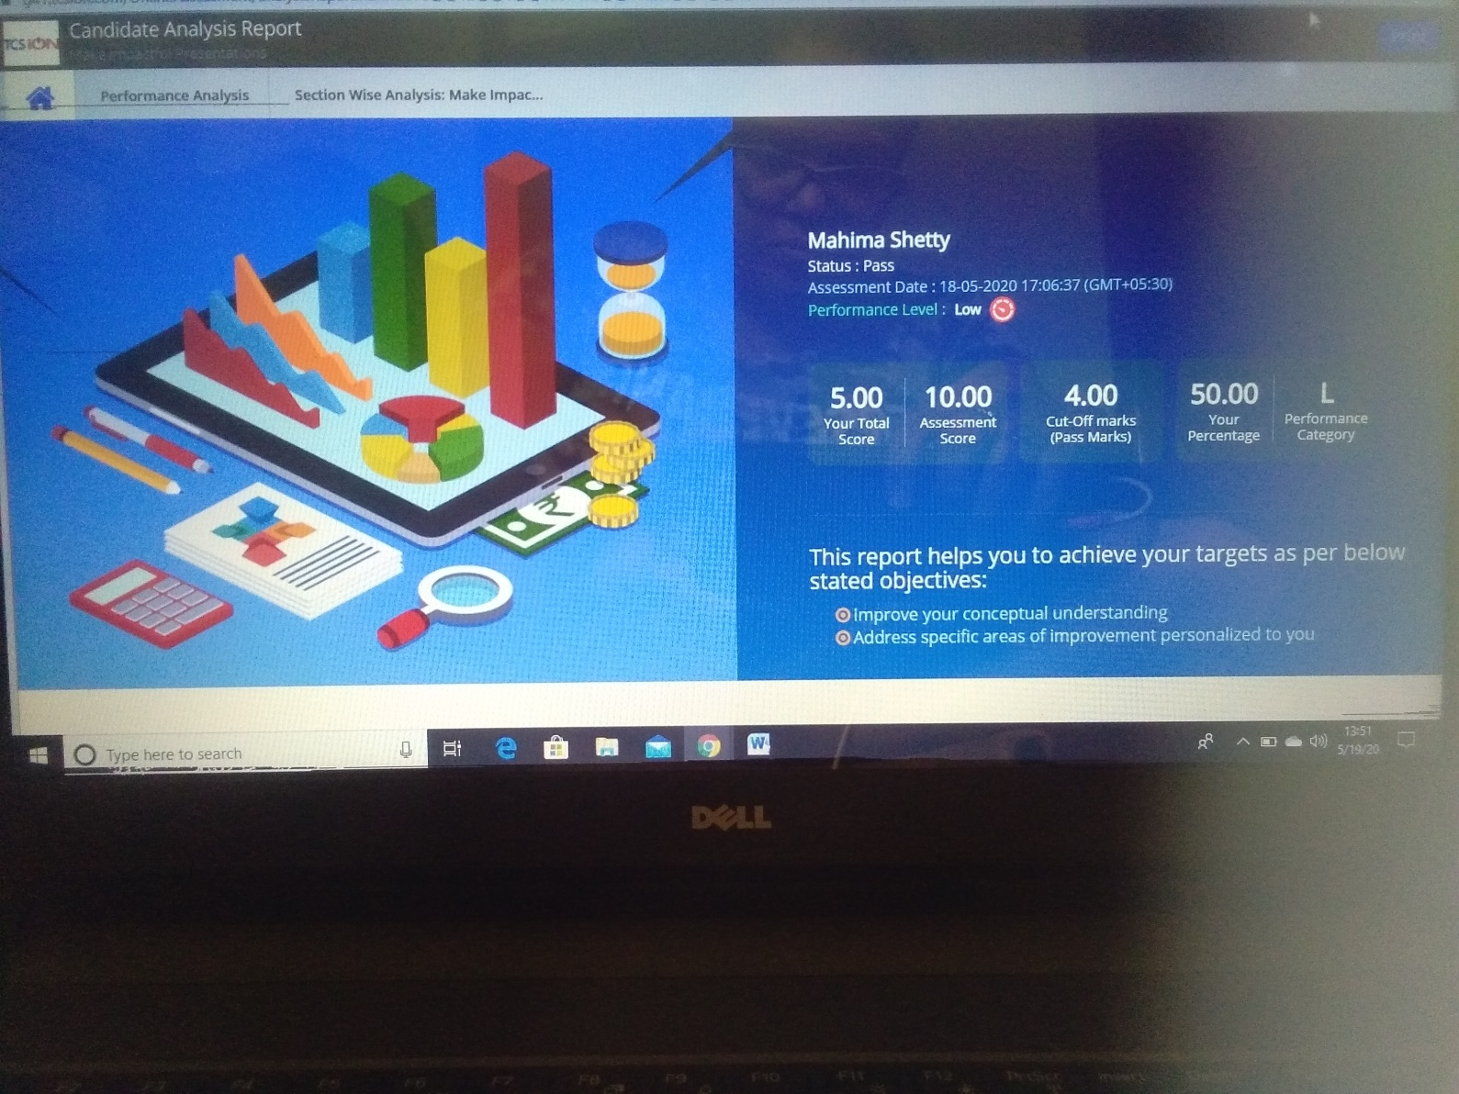

# Communicate to impress

* Importance of communication, process of communication, barriers of communication ,verbal and nonverbal communication.
* What is communication?, why should we communicate?
* Communication can be verbal, nonverbal, visual, written.
* Interacting with people from other countries:Greeting,Stereotyping,Behavior,gestures
* Barriers to communication-Phychological barriers
  + Retention capability
  + Inattentiveness
  + Status
  + Closed mind
  + Source of communication
* Nonverbal communication
  + facial expression
  + paralanguage
  + gestures
  + Posture
  + Eye content
  + Appearance
* Effective communication: DO
  + Maintain eye contact
  + Dress for occasion
  + Speak with clarity
  + Correct posture
  + Positive Gestures
* Effective communication: Avoid
  + Checking your phone while conversing
  + Dressing shabbily

# Deliver presentation with impact

* Design effective PPTs, Make an effective presentation, Dos and don’ts in presentation skills
* 5W’s
  + What
  + Who
  + Why
  + Where
  + When
* A few image per slides
* One thought per slide
* Effective use of quotations
* Readable fonts
* Avoid upper cases
* Attractive slides
* Use images to simplify content
* Background to be simple
* Use visual aids
* Formally dressed
* Knowledge transfer
* Team meeting
* Brain storming

# Develop soft skills for the workplace

* Importance of soft skills, Distinguish hard and soft skills
* Lack of soft skills
* Need for soft skills
* Recognizing the need for soft skills
* Importance of soft skills
* Difference between soft and hard skill